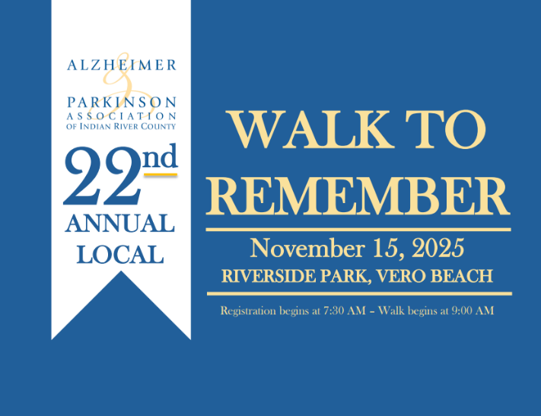**PARTICIPANT REGISTRATION FORM AND WAIVER**

**ALZHEIMER & PARKINSON ASSOCIATION OF INDIAN RIVER COUNTY**

**SATURDAY, NOVEMBER 15, 2025, AT RIVERSIDE PARK**

**Information required for all walkers. Please fill out, sign and date below.**

**NAME: ___________________________________ TEAM NAME: ____________________________**

**E-MAIL: _________________________________________ PHONE: _________________________**

**ADDRESS: _________________________________CITY, STATE, ZIP: _________________________**

**Are you walking in honor or memory of someone? ______________________________________**

**I am supporting the Walk as a: ___Team Captain ___ Team Member ___ Individual Walker**

**ALL WALK PARTICIPANTS MUST SIGN THE FOLLOWING WAIVER:**

The WALK TO REMEMBER is an activity that involves walking, which may include risks such as, but not limited to, falls, interaction with other participants, effects of weather, traffic and conditions of the road. I, as a Participant, hereby expressly assume all risks, including bodily and personal injury, death, property loss or other damages of any kind arising in any way out of my attendance or participation in the WALK TO REMEMBER and related activities. It is my responsibility to dress appropriately. Although route maps, rest stops, refreshments and other assistance may be made available during the event, I am solely responsible for my own health and safety. I represent that I am physically able to attend or participate in this event. I hereby, for myself, my heirs, executors and administrators, release, discharge and agree not to sue the Alzheimer & Parkinson Association of IRC, its respective officers, directors, volunteers, employees, sponsors and agents, and release from any and all liability, claims, demands and causes of action whatsoever, arising out of my participation in or attendance at this event and related activities – whether resulting from the negligence of any of the above or from any other cause. I agree that my assumption of risk and release hereunder shall be as broad and inclusive as is permitted under applicable law. If any portion of this agreement is held invalid, the remainder shall continue in full force and effect. I grant full permission in perpetuity to the organizers of this event to use, reuse, publish and republish my name and image as a participant in the WALK TO REMEMBER event in photographs, video or other recordings. I have read, understand and agree to the terms of this agreement.

If Participant is a minor or acts in accordance with a legal guardian, the parent or guardian must sign and agree to the below: *I am the parent and/or legal guardian of Participant, and I hereby consent to his/her participation. I have read the foregoing agreement, and I hereby agree on behalf of myself and Participant to its terms.*

Signature ______________________________________ Date _________________________

2300 5th Avenue, Suite 150 · Vero Beach FL 32960 · 772.563.0505 [www.alzpark.org](http://www.alzpark.org)

**WALK TO REMEMBER TEAM CAPTAIN AND WALKER FORM**

Your Information as a ___Walker or ___Team Captain:

**NAME: ___________________________________ TEAM NAME: ____________________________**

**E-MAIL: __________________________________________ PHONE: _________________________**

**ADDRESS: _________________________________CITY, STATE, ZIP: _________________________**

**Ask your friends, family, co-workers to help!**

**Please make checks payable to: Alzheimer Parkinson Association of IRC**

|  |  |  |  |  |  |  |  |
| --- | --- | --- | --- | --- | --- | --- | --- |
| Donor's Name | Address, City & State | E-Mail Address | Phone | Amount | Check | Cash | Credit Card |
|  |  |  |  |  |  |  |  |
|  |  |  |  |  |  |  |  |
|  |  |  |  |  |  |  |  |
|  |  |  |  |  |  |  |  |
|  |  |  |  |  |  |  |  |
|  |  |  |  |  |  |  |  |
|  |  |  |  |  |  |  |  |
|  |  |  |  |  |  |  |  |
|  |  |  |  |  |  |  |  |
|  |  |  |  |  |  |  |  |
|  |  |  |  |  |  |  |  |
| **Total Amount Collected:** |  |  |  |  |  |  |  |

2300 5th Avenue, Suite 150 · Vero Beach FL 32960 · 772.563.0505

[www.alzpark.org](http://www.alzpark.org)

A COPY OF THE OFFICIAL REGISTRATION AND FINANCIAL INFORMATION MAY BE OBTAINED FROM THE DIVISION OF CONSUMER SERVICES BY CALLING TOLL-FREE 1-800-HELP-FLA OR ONLINE AT WWW.FLORIDACONSUMERHELP.COM. REGISTRATION DOES NOT IMPLY ENDORSEMENT, APPROVAL, OR RECOMMENDATION BY THE STATE. REGISTRATION #: CH18787

**WALK TO REMEMBER DONATION FORM**

**NAME: ___________________________________ TEAM NAME: ____________________________**

**E-MAIL: __________________________________________ PHONE: _________________________**

**ADDRESS: _________________________________CITY, STATE, ZIP: _________________________**

**Are you supporting:**

**___ A Walker: ____________________________________________________________________**

**___ A Team ______________________________________________________________________**

**___ A General Donation to the Walk to Remember that supports local families struggling with Memory and Movement Disorders.**

**I wish to make a difference for families with Alzheimer’s and Parkinson’s through the Alzheimer & Parkinson Association of Indian River County in the amount of:**

**___$1,000 ___$500 ___$150 ___$75 ___$25 Other Amount: $__________**

**___Enclosed is my check payable to: *Alzheimer & Parkinson Association of IRC***

**___I prefer to pay by credit card: ___ VISA ___MasterCard ___Other**

**Credit Card Number: __________________________________ Expiration Date: ________ CVC:_____**

**A 5% fee will be added to all credit card transactions to cover processing fees.**

**Your Signature: _______________________________________ Today’s Date: ________________**

*Thank you for your important support!*

***Please return this form to the Alzheimer & Parkinson Association***

2300 5th Avenue, Suite 150 · Vero Beach FL 32960 · 772.563.0505

[www.alzpark.org](http://www.alzpark.org)

A COPY OF THE OFFICIAL REGISTRATION AND FINANCIAL INFORMATION MAY BE OBTAINED FROM THE DIVISION OF CONSUMER SERVICES BY CALLING TOLL-FREE 1-800-HELP-FLA OR ONLINE AT WWW.FLORIDACONSUMERHELP.COM. REGISTRATION DOES NOT IMPLY ENDORSEMENT, APPROVAL, OR RECOMMENDATION BY THE STATE. REGISTRATION #: CH18787