**Team Captain Toolkit**

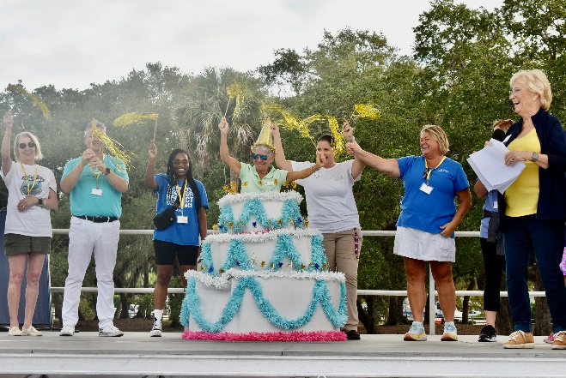

Thank you so much for your willingness to help our community through the Walk to Remember!

As a Team Captain, you play a key role in increasing awareness and funding vital programs and services that help families living with Alzheimer’s and/or Parkinson’s disease.

From recruitment, to fundraising, to the actual walk day, we encourage you and your team to use the tools in this guide to ensure a successful walk experience.

As a Team Captain, we ask that you inspire your family, friends, classmates and colleagues to get involved raising funds that will enable us to continue offering our vital free programs and services to the people of Indian River County.

There are many great suggestions offered in this toolkit. We would be happy to speak to you over the phone or meet with you in person to help you make this your best Walk ever.

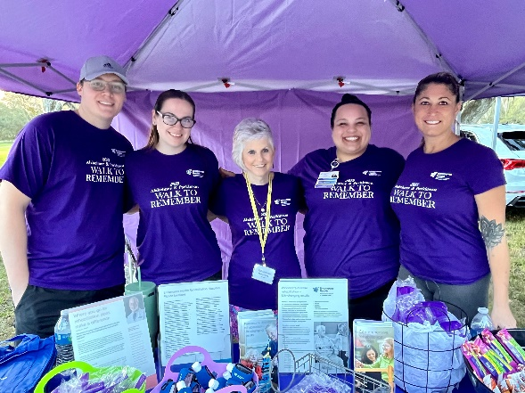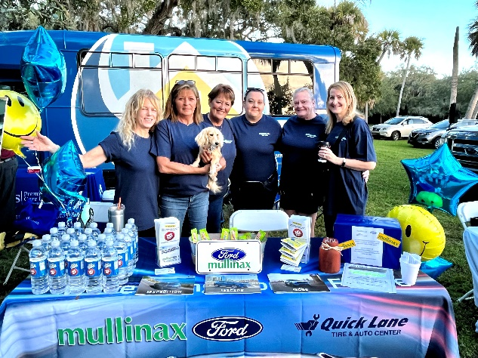

**Getting Started**

Creating Your “Walk to Remember” Team

* Visit our website at [www.alzpark.org](http://www.alzpark.org), click on the **“Annual Events”** tab, and then select **“Walk to Remember.”** From there, you’ll be able to register your team and get all the details you need to participate.

-or-

* Call the local Alzheimer & Parkinson Association office at (772) 563-0505 and we will be happy to register your team for you.

Recruiting Your “Walk to Remember” Team

* Ask your family, friends, classmates and colleagues to get involved. Ask members at your gym, church or any organization you’re associated with to join hands with you.
* If you are involved with local volunteer and social groups, you can encourage them to be part of your team. Be a spokesperson for the cause.
* You can send invitations via your personal e-mail or social media pages. We can also provide Walk to Remember postcards for people who are reached easier via mail.
* To get people inspired to join your team, it’s important that you let them know why this cause is so important. With an estimated 6,800 residents living with Alzheimer's disease and nearly 2,000 people living with Parkinson's disease in our county alone, chances are your teammates know someone struggling with a memory or movement disorder.
* Those who include **why** they are raising money raise **three times** as much as those who do not tell their story.
* 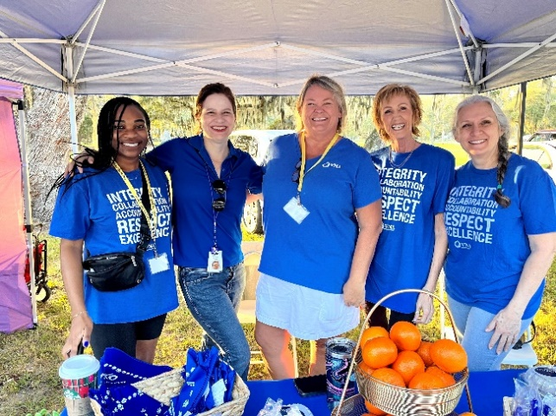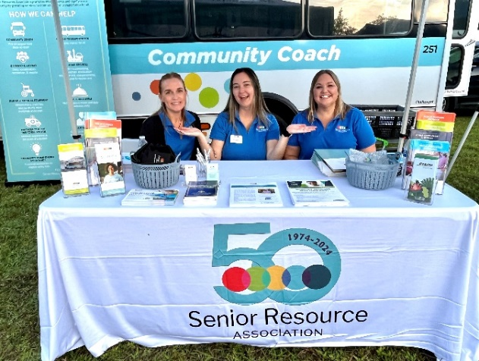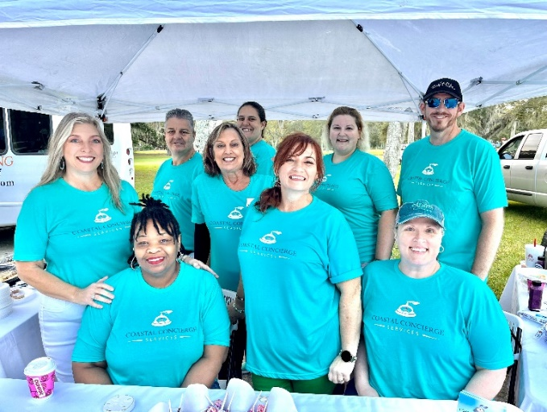

*A small donation can make a huge difference.*

**Fundraising**

As a Team Captain, we encourage you to get creative with your fundraising efforts. Along with your teammates, work together to select activities that will engage teammates and the community to help enlist others and raise funds for the Walk To Remember.

Fundraising tips:

* Kick off your fundraising efforts with a personal donation.
* Plan a team fundraiser. Organize a fun event involving the entire team. This is a great time for your team to bond together.
* Use a variety of communication channels. Focus on building a strong social media presence for your campaign. Recruit some passionate supporters to be ambassadors.
* Never underestimate the value of email. Email is responsible for about one-third of fundraising revenue.
* Who do you know? Ask the people closest to you – the people you interact with every day such as:
  + People at your gym, sports teams, book clubs, place of worship and hobby groups
  + People in your community, neighborhood associations and civic clubs
  + People that you give your business to such as your mechanic, hair stylist, or doctor.
* Fundraise at work. Ask your workplace if you can have a “dress down Friday” to raise donations. Make a badge or sticker for supporters to wear.
* Set a goal. A goal gives you a target to reach while fundraising. Your and your team can measure your progress on your teams’ Walk to Remember website page.
* Start early. Small donations can add up quickly if you start ASAP.
* Be as creative as possible. If it’s fun, everyone will want to “play”.

**Fundraising Ideas**

Fundraising ideas:

* Office Fundraising Challenge – Challenge your office colleagues to raise funds for your team. Hand out homemade fundraising envelopes and provide an award or incentive to the top fundraiser.
* Garage Sale – Spring and Fall are great times to clean out all those unwanted items and host a garage sale for your Walk team.
* Bake Sale - Host a bake sale with your friends, place of work, or at your child’s school.
* Keep the Change – Turn your small change into additional dollars for your fundraising efforts.
* Business Support – Ask local restaurants or other local businesses to place a money jar at the front of their establishment or if they’d be willing to host a fundraising event to benefit your team.
* Bulletin Board at Religious and Community Institutions – Post a flyer, and/or submit an announcement in the newsletter to let everyone know about the Walk and invite them to join your team.
* Karaoke Night – Host a Karaoke night at your local bar and have people give donations to sing.
* Book Sale – Ask your team to find all of their gently used books to sell.
* Ice Cream Social – Everyone loves ice-cream. Host an office get together and don’t forget the toppings.
* Sports Jersey/T-Shirt Spirit Day - Wear your favorite sports jersey or t-shirt to work.
* Gift Baskets – Selling raffle tickets to win a gift basket is a tried and true fundraising method.
* 50-50 Raffle – Another successful and practial fundraiser. Who doesn’t love winning some quick and easy cash?

**Get Social**

Sample posts for Facebook/Linkedin/Instagram:

Make it personal. Share your story. Below are just examples of how team members have shared their stories. Borrow these or create your own. It’s your story!

* I’m walking to help local families dealing with Alzheimer’s and/or Parkinson’s. Over 6,800 people are touched by dementia in Indian River County alone. Follow my footsteps and join my team today! [Link to personal walk page].
* I’m walking to help families dealing with Alzheimer’s and/or Parkinson’s and to honor and remember my [grandma, grandpa, brother, sister]. Please donate to my team today. Together we can make an important difference! [Link to your walk page and upload a photo of the person you are walking for].
* We’re walking to support our local Alzheimer & Parkinson Association of Indian River County on November 4th. Join [team name] or donate to help the families in our community that have been touched by a memory or movement disorder. [Link to your personal walk page].
* I’m at [insert percentage] of my fundraising goal for the Walk to Remember to help our local community members touched by a memory or movement disorder. Please donate and help me reach 100%. [Link to personal walk page].

**Prepare for Walk Day**

As team captain, it’s your moment to shine and to lead the way to energizing your team on this 2.2 mile fun walk around our beautiful Riverside Park!

* **Get organized.**  Make plans with your team for carpooling or where to meet.
* **Plan ahead.** Registration begins at 7:30 am and the Walk begins at 9:00 am. Register ahead of time on our Walk Website to give you plenty of time to locate your team members before the Walk.
* **Show off your team.**  In addition to wearing team t-shirts, you may enjoy making buttons or signs to wear expressing your reasons for wanting to help local families dealing with Alzheimer’s and/or Parkinson’s.
* **Stay in contact.**  The week before the Walk, send a reminder email to your teammates with info of where to meet at Riverside Park. This is a great time to remind them to turn in any remaining donations.
* **Capture the moment.** Be sure to take photos and post updates showing the day’s festivities. This is a great opportunity to thank your donors and start next year’s recruitment.
* **Share your experience.** Meet your team members at the finish line to celebrate your success. Be proud of your efforts and accomplishments! Don’t forget to share this special triumph on social media sites and tag us on Facebook.
* **Gratitude is Contagious.**  Thank all your donors and team members. Those who are shown thanks are more likely to contribute and get involved next year than those who are not thanked.
* **Come together to celebrate.** Plan a post Walk event for your team and share fundraising totals. Recognize the top team members and celebrate your team’s amazing accomplishment!
* **Continue to connect.** This is an important way to keep the excitement and momentum going for next year’s Walk!

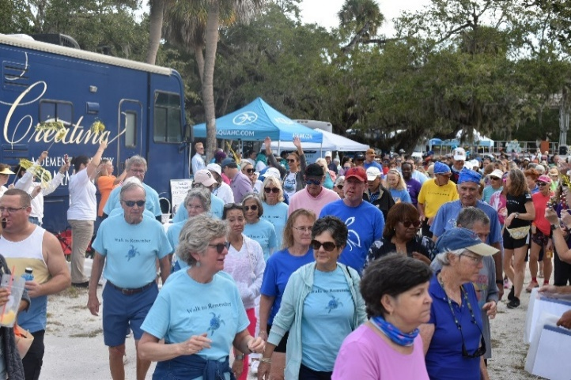

**Frequently Asked Questions**

Q: Is there a fee to participate/sign up a team?

A: No, there is no registration fee of any kind.

Q: How do I sign up my team?

A: Visit [AlzPark.org](http://www.alzpark.org) to sign up your team online, or give us a call at (772) 563-0505 — we’ll be happy to register your team for you!

Q: Does everyone on the Walk team need to fill out a Participant Registration Form & Waiver?

A: Yes, it can be done in advance in person, online, or the day of the Walk.

Q: What if my donors don’t want to donate online?

A: You can always hand your donors a donation form or they can mail a check to our Vero Beach office at 2300 5th Avenue, Suite 150, Vero Beach, FL 32960.

Q: Who should the check be payable to?

A: Checks should be made out to: *Alzheimer and Parkinson Association of IRC*.

Q: Do I have to send in my donations? Can I bring them with me to the Walk?

A: You can drop off donations at anytime to our office. No need to wait until the Walk day, as you donate, we will update your teams page so you can see your progress! The Wednesday and Thursday before the Walk we designate “Bank Days” where you can come to our office with all your donations in checks or cash. Cash receipts are provided at that time. We will also collect any and all donations the day of the Walk.

Q: What happens if it rains on the day of the Walk?

A: The Walk is held rain or shine.

Q: How are the funds raised used?

A: Every dollar raised is used **locally** to support our free programs and services for the people of Indian River County with memory and/or movement disorders and their caregivers.*

*IMPORTANT: It’s important to remember and let any walkers or donors to your team know that we are NOT affiliated with any national organzation including the Alzheimers Assocation. We receive no funding from these organzations or from the government. Any funds raised to benefit these organizations cannot be accepted by us. Checks made out to other organizations cannot be accepted by our organization. We apologize for this confusion or inconvience.